

**Shrek-Juices**

|  |  |  |
| --- | --- | --- |
| **Supervisor:** | *LÊ THANH NHÂN* | |
| **Semester:** | *1* | |
| **Batch No:** | *T1.2004.M1* | |
| **Group No:** | *04* | |
| **Order:** | **Full name** | **Roll No.** |
| *1.* | *VO NGUYEN HOANG QUAN* | *Student1256248* |
| *2.* | *DAO LE DUONG* | *Student1262868* |
| *3.* | *TRAN NGUYEN GIA BAO* | *Student1266804* |



**This is to certify that**

|  |  |
| --- | --- |
| **Mr.** | **VO NGUYEN HOANG QUAN** |
| **Mr.** | **DAO LE DUONG** |
| **Ms.** | **TRAN NGUYEN GIA BAO** |

Have successfully Designed & Developed

|  |  |  |
| --- | --- | --- |
|  |  |  |
| **Shrek-juice** | | |

Submitted by:

|  |
| --- |
| **Mr. LE THANH NHAN** |

Date of Issue:

|  |  |
| --- | --- |
|  | **10/07** |

Authorized Signature:

|  |  |
| --- | --- |
|  |  |

**Project Acknowledge**

eProject is a step-by-step learning environment that closely simulates the classroom and Lab based learning environment into actual implementation. It is a project implementation at your fingertips!! An electronic, live juncture on the machine that allows you to

+ Practice step by step i.e. laddered approach.

+ Build a larger more robust application.

+ Usage of certain utilities in applications designed by user.

+ Single program to unified code leading to a complete application.

+ Learn implementation of concepts in a phased manner.

+ Enhance skills and add value.

+ Work on real life projects.

+ Give a real life scenario and help to create applications more complicated and useful.

+ Mentoring through email support.

**Objectives of the project**

The Objective of this program is to give a sample project to work on real life projects. These applications help you build a larger more robust application.

The objective is not to teach you JavaScript/Dreamweaver but to provide you with a real life scenario and help you create basic applications using the tools.

You can revise the chapters before you start with the project.

This project is meant for students who have completed the module of ***HTML5***. These programs should be done in the Lab sessions with assistance of the faculty if required.

It is very essential that a student has a clear understanding of the subject. Students should go through the project and solve the assignments as per requirements given.

Kindly get back @ [eprojects@aptech.ac.in](mailto:eprojects@aptech.ac.in) in case of any doubts regarding the application or its objectives.

**Synposis**

Shrek-Juice.com is a website of the Shrek Juice Centre which is big Juice Centre famous for variety of juices it provides. They also provide catering service for various events like Wedding, Shows and so on.

**Problem Defination**

With include of new type of juices and also thought of changing the lookalike of the website the owner wish to renovate the look and feel of the website which should be more catchy and helpful for the business perspective.The website is to be developed for the Windows Platform using HTML5, JavaScript and Geolocation. The site should work well in all leading browsers including Chrome, IE, Firefox etc.

**Functional Descriptions**

The website will be created based on the following model.

- Home

- Menu

i. Fruit juices

ii. Vegetable Juices

iii. Smoothies

iv. Protein Shakes

v. Winter Menu

vi. Chocolate Juices

vii. Mock Tails

- Store Location

- Franchising

- Catering

- Feedback

- About us

*User:*

* Access and refer to the information placed on the website
* Contribute ideas, feedback or suggestions

*Webmaster:*

* Change the content, images and layout of the website.

**Customer Requirement Specification**

1. The Home Page should be created making use of Sections with a suitable logo
2. Few tips can be included in the blank space area of the webpage.
3. The Menus must be included in the website
4. There should be a “Contact Us” page which will have the Address of the Company which should be displayed using GeoLocation API (eg. GoogleMaps) and the email address which when clicked will invoke the local mail client from where they can send an email.

**Hardware / software requirement**

**User:**

• PC: from Pentium 166 or upper

• RAM: from 64 Megabites or upper

**Webmaster:**

• Notepad/HTML editor

• Dreamweaver

• IE 5.0/ Netscape 6.0

**Architecture and Design of the Project**

Server

Device

Windows Platform

Client

HTML

CSS

Javascript

Jquery

Bootstrap

**Site Map**

**Screenshot**

Home page

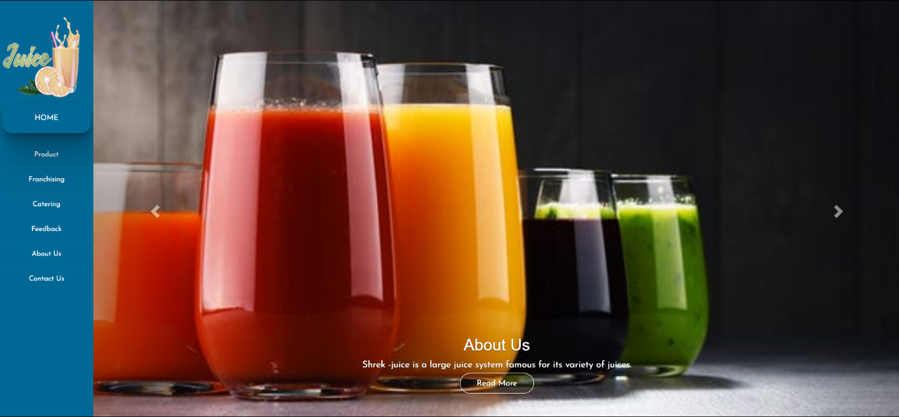

Feedback

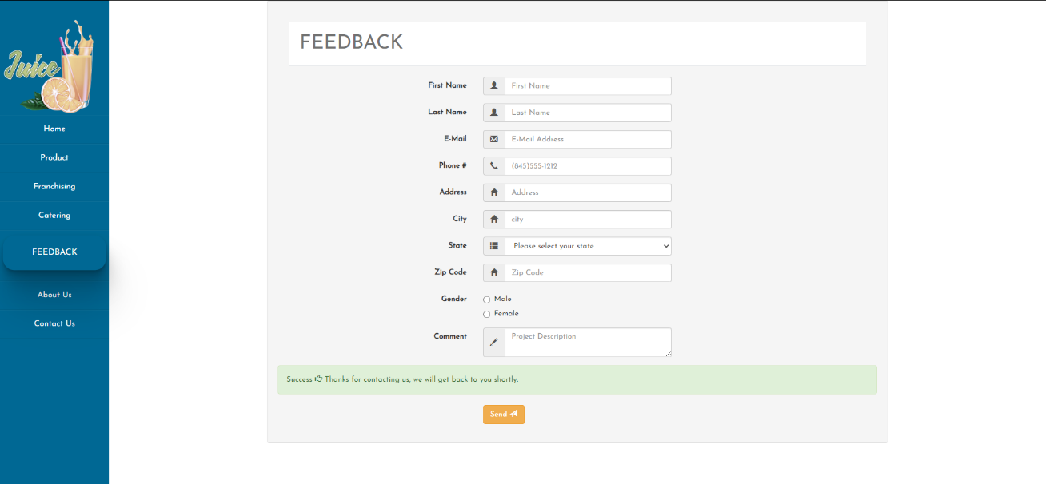

Franchising

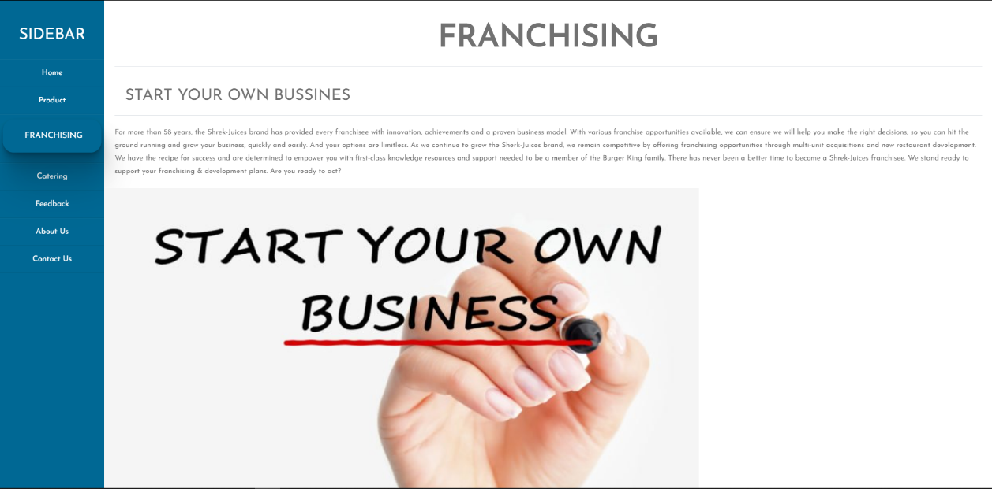

Product

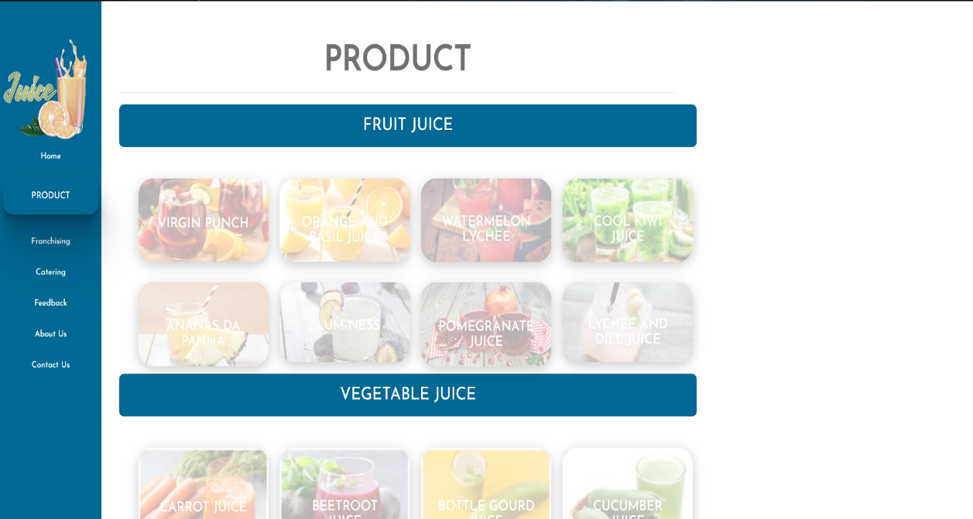

About Us

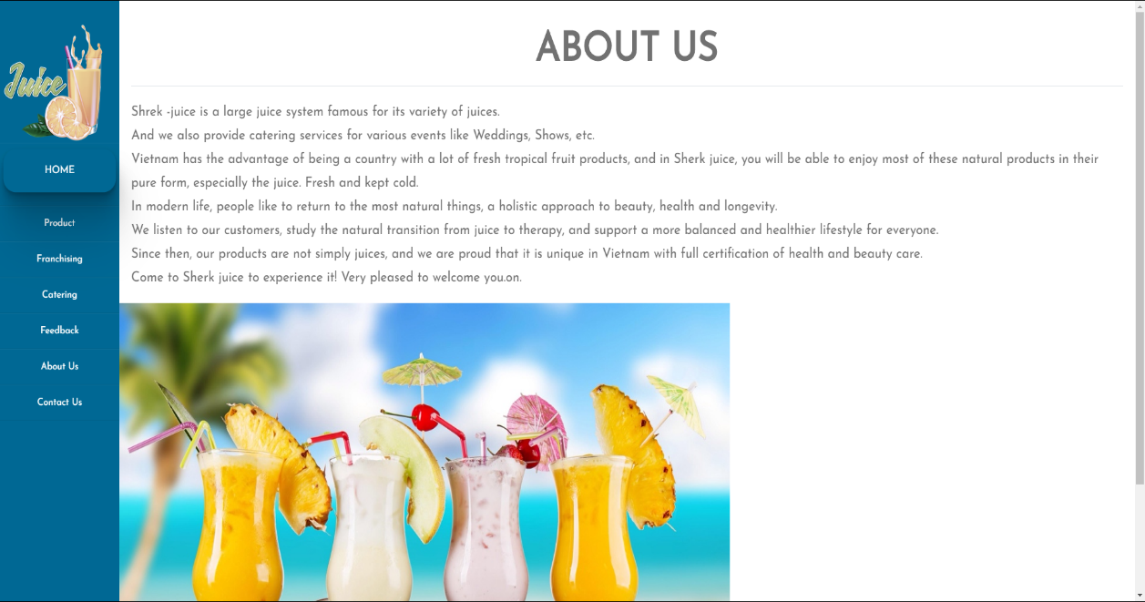

Contact us

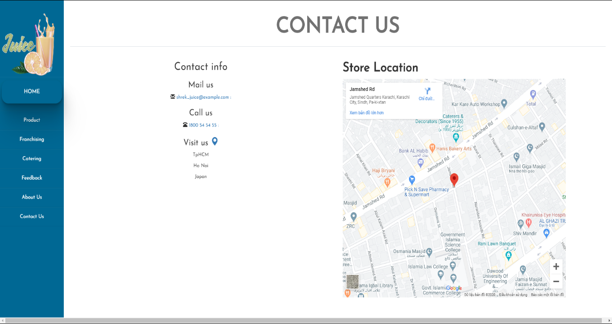

Catering

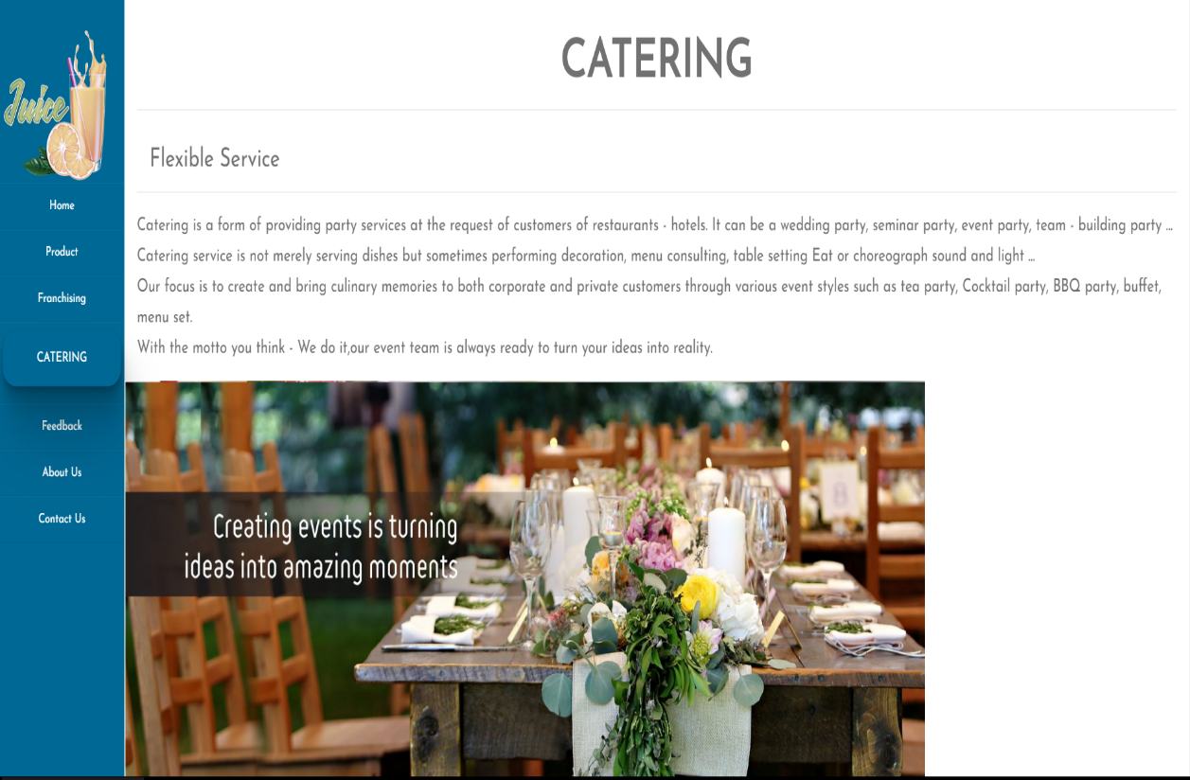

**Testing Document**

Vadilation form:

* First name cannot left blank.
* Last name cannot left blank.
* Phone cannot left blank.
* Comment cannot left blank.

**Final Checklist**

Checklist Validation

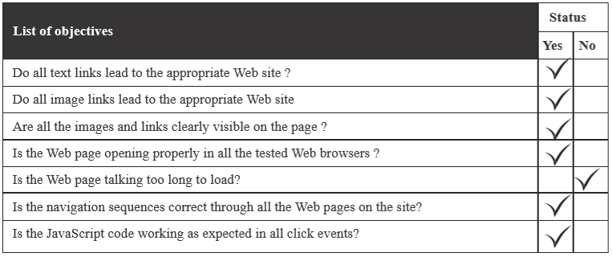

Submission Checklist

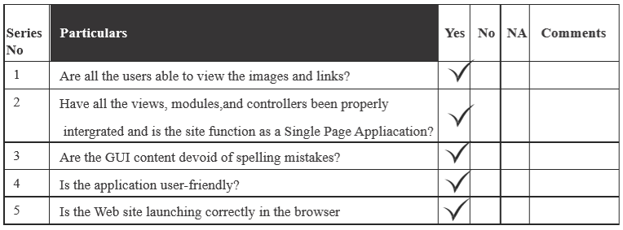

**Task Sheet**

